**Github Repo is:** <https://github.com/sfc-gh-jjordan/Snowpark_HOL_End_to_End_Data_Science_DBX>

**Steps:**

1. Create a new Streamlit app in Snowflake under the left hand navigation under Projects–Streamlit and click the +Streamlit App button in the top right corner
2. Name the app Snowpark_HOL_AppX (where X is your assigned user#)
3. Change the DB to HOL and Schema to SCHEMAX based on your assigned user#
4. Set the virtual warehouse to WHX based on your assigned user#

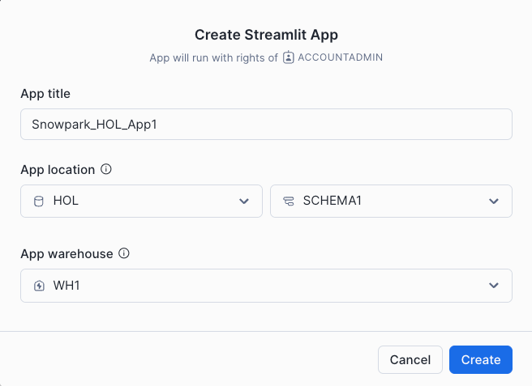

1. Edit the app code and replace all the sample code with provided app code in SIS_application.py
2. Include the required packages in the UI under the Packages drop-down at the top:
   1. numpy
   2. pydeck
   3. Snowflake-ml-python
   4. python, snowflake-snowpark & streamlit will be added by default

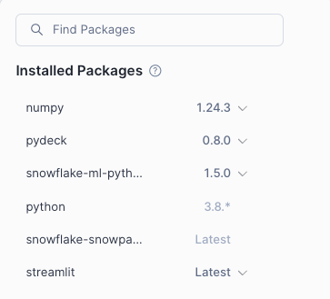

1. Ctrl-lF to Find & Replace all SCHEMA0 with SCHEMAX based on your assigned user#
2. Run the Streamlit app
3. In the app choose a City & Shift (AM or PM)
4. Adjust the number of Food Trucks and the Minimum Distance between Trucks
5. Click Update and scroll down to the map
6. Navigate and Zoom In/Out to see 3D Bar Chart with the Predicted Shift Sales by location
7. Scroll down to the next map to see the recommended locations based on the number of Food Trucks and minimum distance selected